### Homework 7_2

**Problem 1:**

% Define the coordinates of the points

x = [0, 4, 4, 6, 10];

y = [0, 8, -5, 0, 0];

% Calculate the integral using trapezoidal rule

integral_value = trapz(x, y);

% Display the integral value

disp(['Integral Value: ', num2str(integral_value)]);

% Calculate the cumulative integral values

cumulative_integral = cumtrapz(x, y);

% Plot the original function

figure;

subplot(2,1,1);

plot(x, y, 'bo-', 'LineWidth', 2);

title('Original Function');

xlabel('x');

ylabel('y');

% Set x-axis and y-axis limits

xlim([0, 10]);

ylim([-10, 10]);

% Plot the integral

subplot(2,1,2);

plot(x, cumulative_integral, 'ro-', 'LineWidth', 2);

title('Integral of the Function');

xlabel('x');

ylabel('Integral Value');

sgtitle('Function and its Integral');

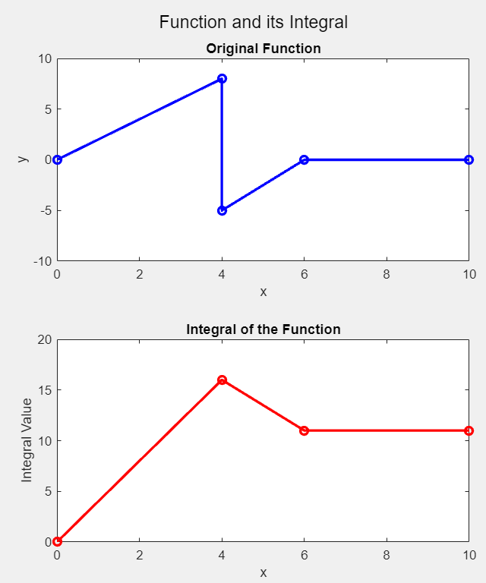

**Problem 2:**

Same M file with different coordinates

% Define the coordinates of the points

x = [0, 4, 8, 12];

y = [5, -5, 5, -5];

